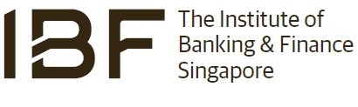

|  |  |  |
| --- | --- | --- |
| WHISTLE-BLOWING FORM | | |
| Please provide the following details to report any suspected misconduct. Please note that you may be called upon to provide clarification to assist with the investigation. | | |
| Your details (optional) | | |
| Name |  | |
| Designation |  | |
| Company’s name |  | |
| Contact number |  | |
| Email address |  | |
| Details of Individual / Entity Suspected of Misconduct | | |
| Name |  | |
| Designation |  | |
| Identity number  *(e.g. NRIC no. – individual; UEN – business)* |  | |
| Registered address |  | |
| Contact number |  | |
| Email address |  | |
| Witness details (if any) | | |
| Name |  | |
| Designation |  | |
| Company’s name |  | |
| Contact number |  | |
| Email address |  | |
| Description of the Misconduct | | |
| 1. What happened? | | |
| 2. When did it happen and/ or when did you notice it? | | |
| 3. Where did it happen? | | |
| 4. How did it happen and/ or how did you notice it? | | |
| 5. Have you approached the person? If yes, what did he/she say or respond? | | |
| 6. Were other people involved? If yes, who are they? | | |
| 7. Is there any evidence that you could provide us? | | |
| 8. Please provide any other details or information which would assist us in the investigation. | | |
| 9. Have you reported the misconduct through other channels? If yes, to whom or which organisation you have made the report? | | |
| Date: | | Signature: |
| Please send the completed report to: | | |
| E-mail:  whistleblow@ibf.org.sg | | Mail:  Risk and Governance  10 Shenton Way #13-07/08  MAS Building, Singapore 079117 |

Updated: Apr 2023

# CONFIDENTIAL